Online CCA Registration
USER GUIDE for
STUDENTS

Table of Contents

Login 1
CCA Registration 3
Print Confirmation Slip 4
Sample Confirmation Slip 5

Login
URL: https://mayflower.schoolhub.sg/

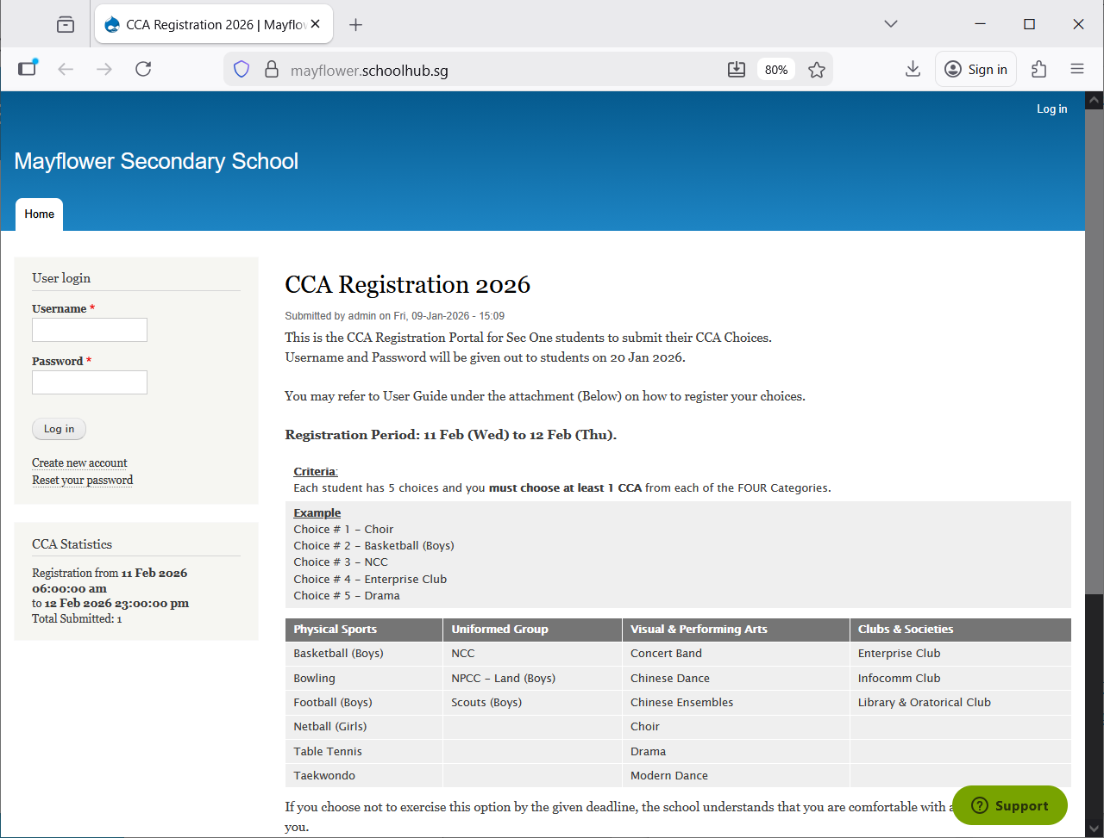

Steps
- Enter Username
- Enter Password
- Click Log in button

Upon successful login, you will be able to see the CCA Registration link under Pupil Menu.

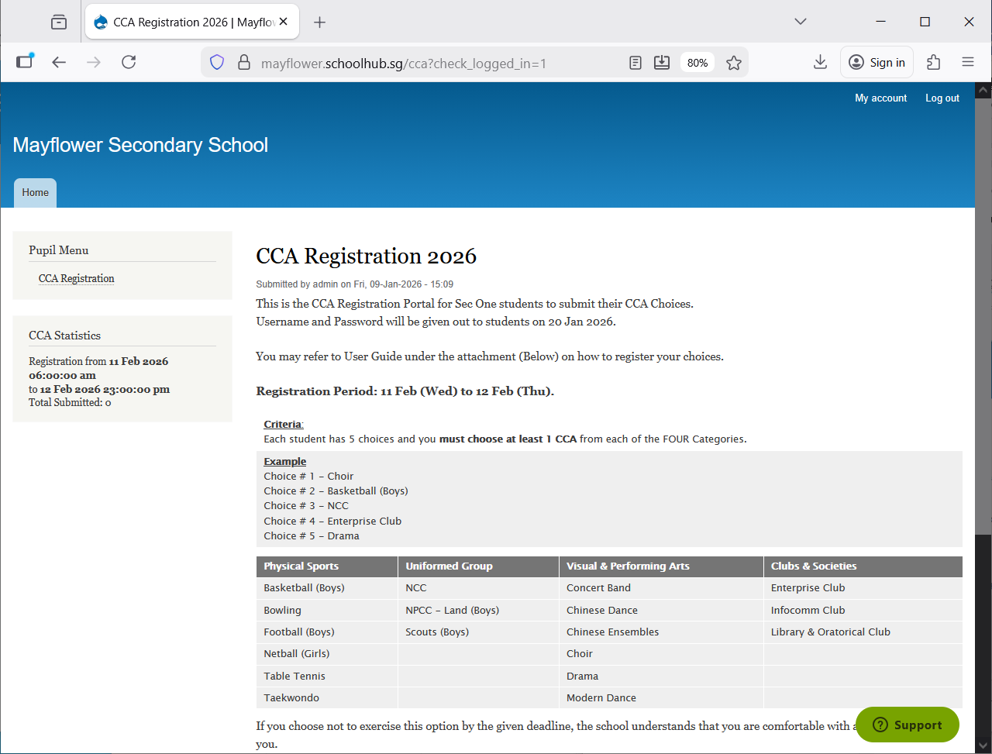
CCA Registration
Read the Announcements

Steps
- Click on CCA Registration button to begin

CCA Registration
If you have not registered, you will see this message: “You have not submitted yet”.
Click Register to begin
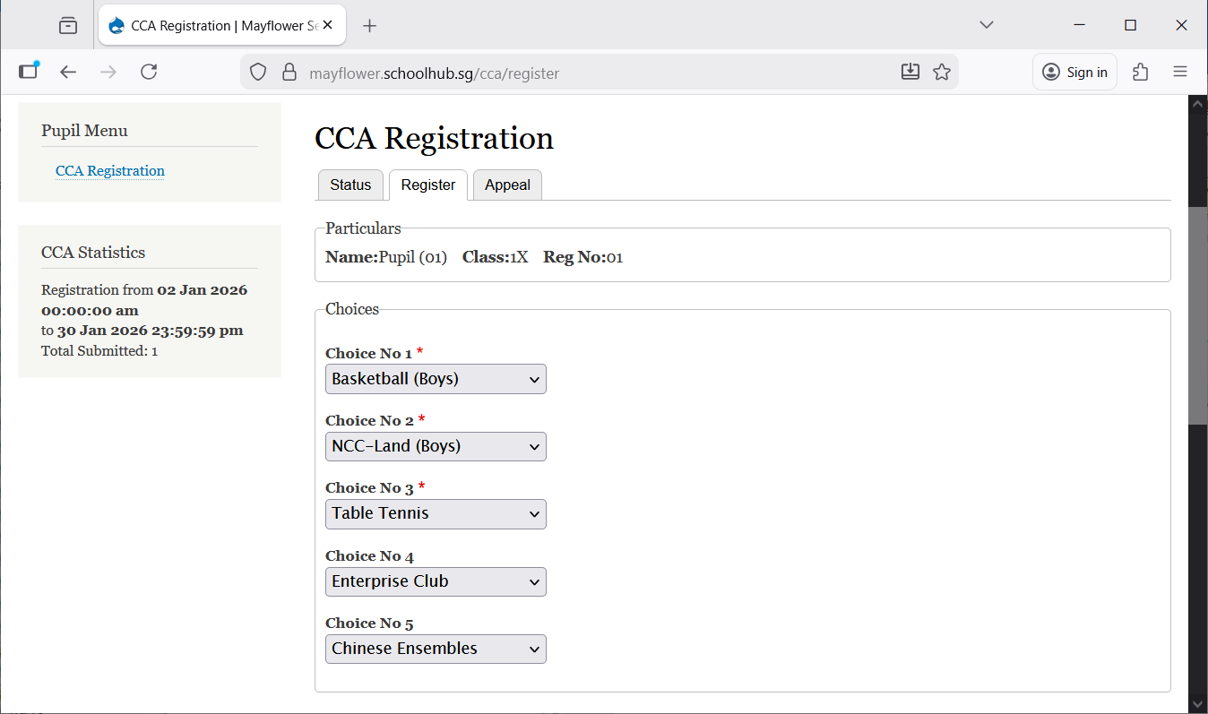
Enter all the choices

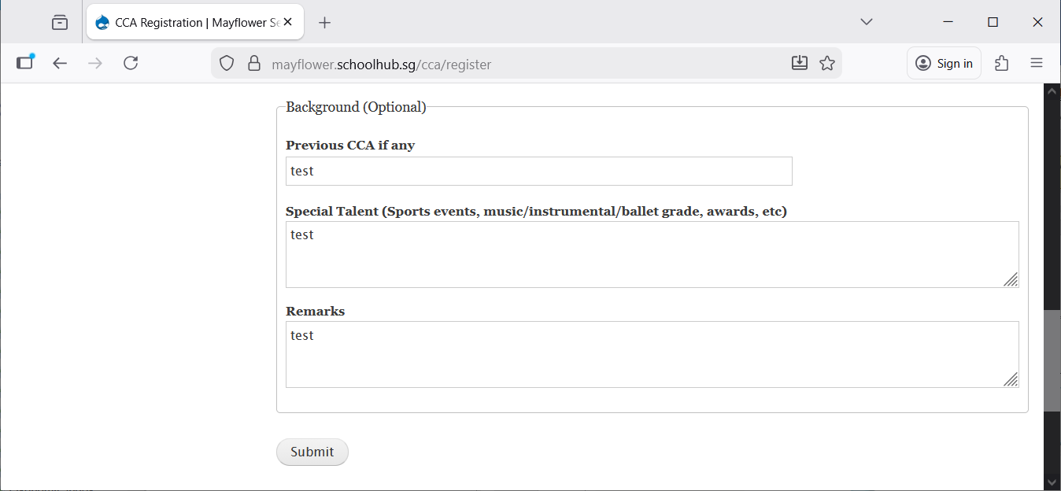
Your remarks for CCA Teacher if you have

Steps
- Select your CCA (Choice No 1 to 5)
- Enter Background info (Optional)
- Click Submit button

Print Confirmation Slip
Once you have clicked Submit, you will be redirected to the Status Tab where your choices will be displayed.
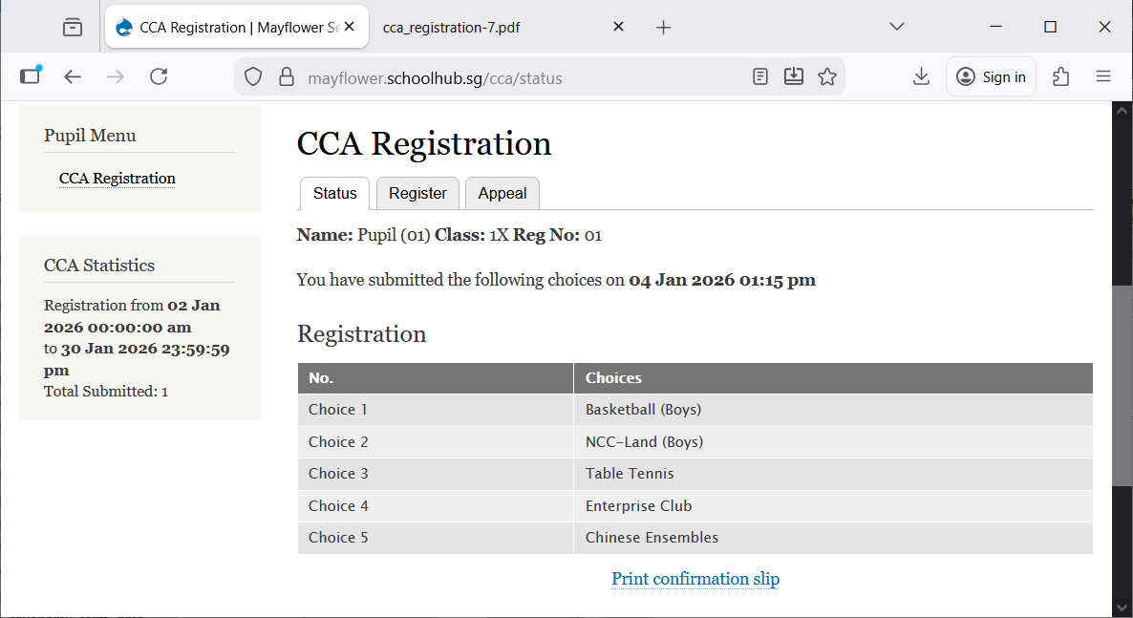

Steps
- Click Print Confirmation Slip button (to save a PDF copy of your submission)

Sample Confirmation Slip
